PEMERINTAH KABUPATEN GUNUNGKIDUL
DINAS PENDIDIKAN PEMUDA DAN OLAHRAGA
PENILAIAN TENGAH SEMERTER II
(PTS-II)
UPT PAUD DAN SD KECAMATAN PANGGANG
TAHUN PELAJARAN 2017/2018

Kelas : 1 (Satu)  Mata pelajaran : B. Jawa | Hari/Tanggal : Kamis, 15-03-2018  Pukul : 07.30 – 08.30
Waktu : 60 menit

Wacane kang patitis!

resikan

saben dina jemuwah
bu guru mriksa bocah-bocah
bu guru dhawuh
bocah-bocah kudu resik lan rapi
kuku dikethoki
rambut dijungkati
klambi dibenakake
bukune ditata

- wangsulana pitakon-pitakon iki kang trep karo wacan.
- kapan bu guru mriksa bocah-bocah?
wangsulan : ....................................................................................
- sapa sing dhwuhi bocah-bocah?
wangsulan : ....................................................................................
- bocah-bocah kudu ngopo?
wangsulan : ....................................................................................
- apa sing dijungkati?
wangsulan : ....................................................................................
- kepriye klambine?
wangsulan : ....................................................................................
- Wenehana tandha ping (x) ing aksara a, b, utawa c wangsulan sing paling trep !
- karo kanca kudu sing ....
- jothakan
- rukun
- tukaran
- mbakyu karo adhi kudu ....
- ditresnani
- dinakali
- dimungsuhi
- yen arep mangkat sekolah ... ibune
- kandha
- pamit
- muni
- nina pamit arep ....
- jejeg
- wungkuk
- dhoyong
- yen mlaku nurut pinggir ....
- kiwa
- tengen
- tengah
- tari gawe sapu ....
- sadha
- sada
- sida
- banu karo dimas bijine ....
- pada
- padu
- padha
- anak pitik iku arane ....
- kutuk
- khutuhuk
- kuthuk
- marang bapak lan ibu kudu ....
- wani
- ngeyel
- ngajeni
- semar iku omahe ing ....
- ngastina
- karang tumaritis
- ngamarta
- simbah sampun ….
- adus
- siram
- gebyur
- bu guru sampun ….
- teka
- tindhak
- rawuh
- petruk iku awake …..
- cendhek cilik
- cilik dhuwur
- cendhek lemu
- semar, gareng, petruk, bagong diarani ….
- pandhawa
- punakawan
- wayang
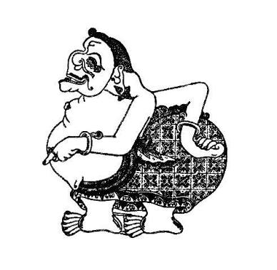
- wayang iki jenenge ….
- bagong
- semar
- gareng

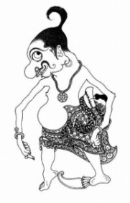
- isenana ceceg-ceceg iki kanthi tembung sing bener!
- gambar wayang iki arane ....

- kula maem, simbah ....
- sing becik yen adus sedina kaping ....
- satriya budi pekertine ....
- klambi sing reged kudu di ....
- yen during ngerti kudu ....
- yen ana tamu diaturi ....
- kancamu tiba becike ....
- petruk iku kakangne ….
- punakawan iku cacahe ….

- salinen ukara-ukara iki kanthi bener
- punakawan ana papat

- semar, gareng, petruk, lan bagong

- momong satriya pandhawa

- satriya budi pekertine luhur

- setya marang negarane

kunci jawaban bahasa jawa kls 1

- saben dina jemuwah
- bu guru
- resik lan rapi
- rambut
- dibenikake

6 | b | 11 | b | 16 | b
7 | a | 12 | b | 17 | c
8 | b | 13 | c | 18 | b
9 | a | 14 | c | 19 | b
10 | a | 15 | b | 20 | b

- gareng
- dhahar
- 2
- luhur
- kumbah
- takon
- mlebu
- ditulungi
- bagong
- 4

kawicaksanan guru

Skor Penilaian :
Bentuk Soal | Jumlah Soal | Skor | Jumlah Skor
Pertanyaan Bacaan | 5 | 2 | 10
Pilihan Ganda | 15 | 1 | 15
Isian singkat | 10 | 2 | 20
Menulis | 5 | 3 | 15
Skor Maksimal |  |  | 60

Nilai : $\frac{skor perolehan}{skor maksimal} ×100$

